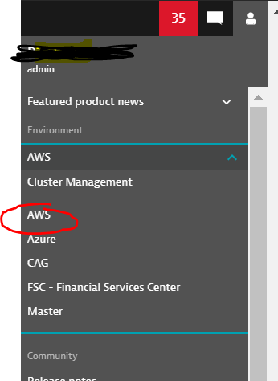
When in the correct environment select AWS in the left hand column
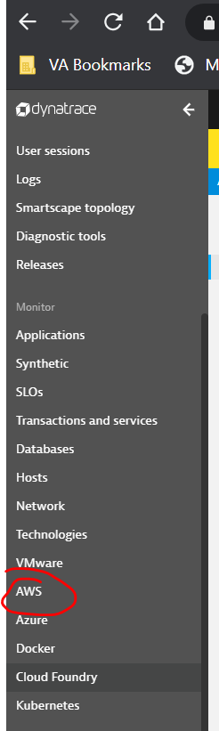
After you select the AWS monitor please select “ALL” or apply the filter necessary to see your specified project team. 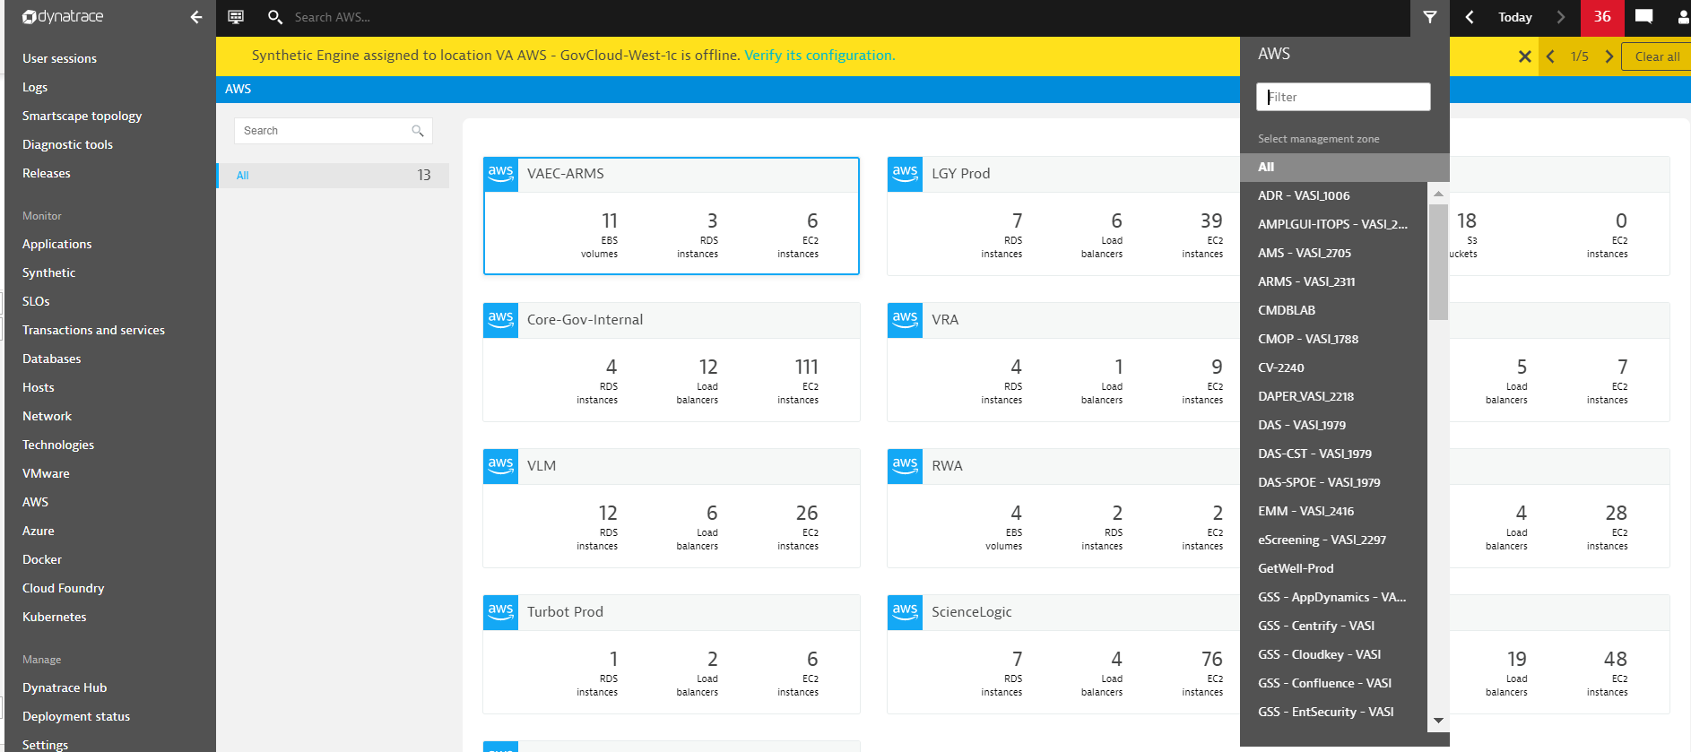

After you click your project team you should come to this screen below. Where you can click any of the blue boxes to obtain more information about that specific service
